SOFTWARE REQUIREMENTS SPECIFICATION

**For**

**Event Management System**

**Prepared by:-**

*Jayavardhini. M*

*Nithiya Prabha. R*

*Pooranidevi. S*

# Introduction

## Purpose

## The purpose of this Software Requirements Specification (SRS) document is to outline the requirements and specifications for the development of an Event Management System. This system is designed to facilitate efficient management of events, including registrations, schedules, and ticket sales. The primary users of this system include event organizers, attendees, check-in staff, and administrators. The system also enhances communication between organizers and attendees, ensuring a smoother and more engaging experience for all involved. With features like data analysis and reporting, an EMS enables organizers to make informed decisions and improvements for future events.

## Document Conventions

* + - Entire document should be justified.
    - Convention for Main title

Font face: Times New Roman Font style: Bold

Font Size: 14

* + - Convention for Sub title

Font face: Times New Roman Font style: Bold

Font Size: 12

* + - Convention for body

Font face: Times New Roman Font Size: 12

## Scope of Development Project

## The Event Management System project aims to create an internet-based platform for seamless event planning and participation. It will provide event organizers with tools for event creation, scheduling, and promotion, while attendees can register and purchase tickets. The system will include features such as ticket scanning, check-in, and reporting. It is designed for flexibility, allowing easy modifications and future enhancements. The development will use Java for its advantages in performance, cross-platform compatibility, and development tools.

## Definitions, Acronyms and Abbreviations

JAVA -> platform independence SQL-> Structured query Language ER-> Entity Relationship

UML -> Unified Modeling Language

IDE-> Integrated Development Environment SRS-> Software Requirement Specification

## References

* + - Websites

**<https://www.academia.edu/38112670/SRS_Event_Management_System>**

**<https://www.scribd.com/document/479330208/Event-Management-docx>**

# Overall Descriptions

## Product Perspective

Use Case Diagram of Event Management System

Top of Form

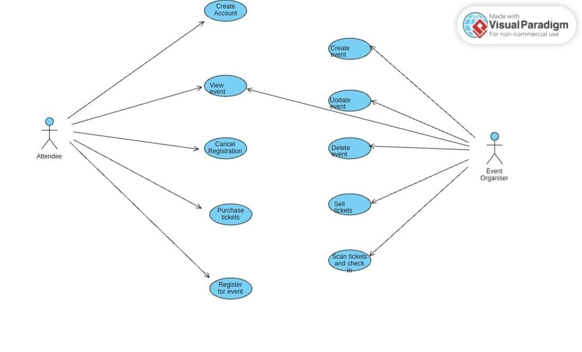

Top of Form

This use case diagram incorporates functionalities for the Attendee, such as canceling registrations, purchasing additional tickets, providing feedback, and checking the status of their check-in at the event venue and the event organizer to create, update, delete event and sell tickets.

## Product Function

Entity Relationship Diagram of Library Management System

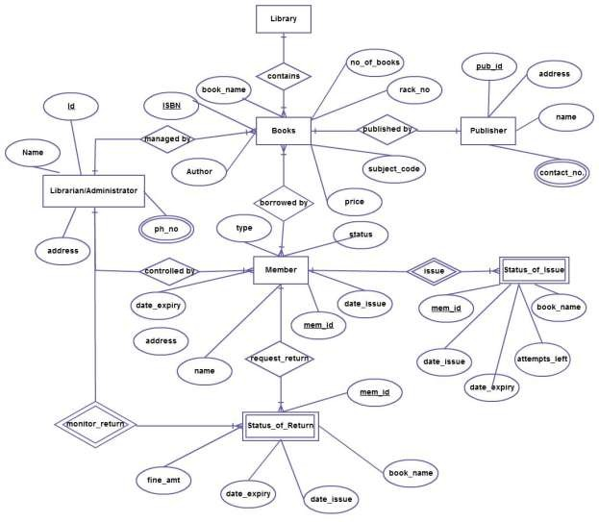

The Online Library System provides online real time information about the books available in the Library and the user information. The main purpose of this project is to reduce the manual work. This software is capable of managing Book Issues, Returns, Calculating/Managing Fine, Generating various Reports for Record-Keeping according to end user requirements. The Librarian will act as the administrator to control members and manage books. The member’s status of issue/return is maintained in the library database. The member’s details can be fetched by the librarian from the database as and when required. The valid members are also allowed to view their account information.

## User Classes and Characteristics

The features that are available to the Admin are:-

* Can issue event tickets to attendees.
* View different categories of events available.
* View the list of events in each category.
* Manage the return of tickets from attendees.
* Add new events and their information to the system.
* Edit the details of existing events.
* Check reports on the existing events.
* Check reports on issued event tickets.
* Access and manage all attendee accounts.

The features that are available to the Members are:-

* View different categories of events available.
* View the list of events in each category.
* Own an account in the event management system.
* View the event tickets issued to them.
* Put in requests for new events.
* View the history of events attended.
* Search for specific events.

## Operating Environment

The product will be operating in windows environment. The Library Management System is a website and shall operate in all famous browsers, for a model we are taking Microsoft Internet Explorer,Google Chrome,and Mozilla Firefox.Also it will be compatible with the IE 6.0. Most of the features will be compatible with the Mozilla Firefox & Opera 7.0 or higher version. The only requirement to use this online product would be the internet connection.

The hardware configuration include Hard Disk: 40 GB, Monitor: 15” Color monitor, Keyboard: 122 keys. The basic input devices required are keyboard, mouse and output devices are monitor, printer etc.

## Assumptions and Dependencies

The assumptions are:-

* + - The coding should be error free
    - The assumption is made that users, both administrators (Librarians) and attendees (Members), have a basic level of technological literacy to navigate and interact with the Event Management System.
    - It is assumed that the system will be deployed on a secure and reliable server infrastructure to ensure continuous availability and data security.
    - The availability of a stable internet connection is assumed for both users and administrators to access and operate the system seamlessly.
    - The Event System is running 24 hours a day
    - Users must have their correct usernames and passwords to enter into their online accounts and do actions

The dependencies are:-

* + - The specific hardware and software due to which the product will be run
    - On the basis of listing requirements and specification the project will be developed and run
    - The end users (admin) should have proper understanding of the product
    - The system should have the general report stored
    - The system relies on external payment gateways for processing financial transactions related to ticket sales, assuming a secure integration with trusted third-party services.
    - Integration with social media platforms for event promotion assumes the availability and compatibility of APIs to facilitate seamless data exchange.

## Requirement

Software Configuration:-

This software package is developed using java as front end which is supported by sun micro system. Microsoft SQL Server as the back end to store the database.

Operating System: Windows NT, windows 98, Windows XP Language: Java Runtime Environment, Net beans 7.0.1 (front end) Database: MS SQL Server (back end)

Hardware Configuration:- Processor: Pentium(R)Dual-core CPU Hard Disk: 40GB

RAM: 256 MB or more

## Data Requirement

## Event Management system includes essential event details such as names, descriptions, dates, and locations. Attendee data, encompassing names, contact information, preferences, and registration history, is crucial for seamless attendee management. Financial transactions data, including payment information, transaction history, and receipts, ensures secure and transparent financial processes. Promotional data, integrating social media, discounts, and marketing campaign details, supports effective event promotion. Additionally, security data, covering user authentication, access logs, and encryption keys, is vital to safeguard sensitive information. Collectively, these data elements form the backbone of the system, enabling organizers to create, manage, and promote events while ensuring the security and privacy of all stakeholders involved.

# External Interface Requirement

## GUI

## A robust graphical user interface (GUI) is crucial for both users and administrators, ensuring a seamless experience. Users, including event organizers and attendees, can perform essential tasks such as event creation, updates, and detailed event viewing through an intuitive GUI. Key features of the GUI include the ability for users to generate quick reports, such as attendance metrics within specific time frames, facilitating real-time insights.

* + - The GUI is designed with customizability in mind, allowing administrators to tailor the interface to their preferences
    - The user interface must be customizable by the administrator
    - All the modules provided with the software must fit into this graphical user interface and accomplish to the standard defined
    - The design should be simple and all the different interfaces should follow a standard

template

* + - The user interface should be able to interact with the user management module and a part of the interface must be dedicated to the login/logout module

Login Interface:-

The login interface is user-friendly, allowing unregistered users to create accounts and prompting login credentials thereafter. Error messages appear for incorrect entries, enhancing the security of the access process.

Search:-

The member can enter the type of event he is looking for , ,then he can search for the required event by entering the event name.

Categories View:-

The Category View provides a comprehensive overview, displaying additional information such as the number of events within each category.

admin’s Control Panel:-

This control panel will allow librarian to add/remove users; add, edit, or remove a resource. And manage lending options.

# System Features

The users of the system should be provided the surety that their account is secure. This is possible by providing:-

* Users are authenticated using a unique identifier, such as a member ID, ensuring secure access to the system.
* Validation mechanisms verify user credentials, providing a reliable and personalized login process.
* Administrators have tools for comprehensive monitoring, allowing them to update account statuses and oversee user activities.
* Popup notifications alert administrators when a member attempts to issue more tickets than the allowed limit, ensuring policy compliance.

# Other Non-functional Requirements

## Performance Requirement

## Performance requirements collectively ensure that the Event Management System delivers a responsive, scalable, and reliable experience for users, administrators, and event organizers, meeting the demands of diverse interactions within the system. Regular monitoring and optimization processes are integral to maintaining optimal performance over time.

* + - The performance of the system should be fast and accurate
    - Security measures, including encryption and authentication, should be implemented without significantly impacting system performance, ensuring that user data remains secure. The system undergoes rigorous load testing to simulate peak usage scenarios, identifying and addressing any performance bottlenecks.
    - The system should be able to handle large amount of data. Thus it should accommodate high number of books and users without any fault

## Safety Requirement

The database may get crashed at any certain time due to virus or operating system failure. Therefore, it is required to take the database backup so that the database is not lost. Proper UPS/inverter facility should be there in case of power supply failure.

## Security Requirement

* + - System will use secured database
    - Normal users can just read information but they cannot edit or modify anything except their personal and some other information.
    - System will have different types of users and every user has access constraints
    - Proper user authentication should be provided
    - No one should be able to hack users’ password
    - There should be separate accounts for admin and members such that no member can access the database and only admin has the rights to update the database.

## Requirement attributes

* + - There may be multiple admins creating the project, all of them will have the right to create changes to the system. But the members or other users cannot do changes
    - The project should be open source
    - The Quality of the database is maintained in such a way so that it can be very user friendly to all the users of the database
    - The user be able to easily download and install the system

## Business Rules

## In the Event Management System, key business rules are enforced to ensure secure and efficient operation. Only authenticated event organizers have the authority to create, modify, or delete events. Attendee registrations require accurate information, tied to unique identifiers. Financial transactions, such as ticket sales, adhere to industry-standard security protocols. Events and ticketing processes must comply with legal and regulatory standards. Access controls are implemented to manage user permissions, preventing unauthorized access. All user interactions are logged for auditing, and regular security audits maintain system integrity. These business rules collectively uphold the reliability, security, and compliance of the Event Management System.

## User Requirement

## Users of the Event Management System require an intuitive platform with tools for seamless event creation, attendee registration management, and a comprehensive ticketing system. For event organizers, features include promotional tools, analytics for attendee insights, and robust security controls. Attendees seek a user-friendly registration process, transparent ticket purchasing, and mobile accessibility. System administrators need user management tools, robust security measures, regular data backups, compliance checks, and responsive support services. The system must facilitate efficient event promotion, streamline attendee interactions, and ensure secure and user-friendly experiences for all stakeholders.

## The admin provides certain facilities to the users in the form of:-

* + - Backup and Recovery
    - Forgot Password
    - Data migration i.e. whenever user registers for the first time then the data is stored in the server
    - Data replication i.e. if the data is lost in one branch, it is still stored with the server
    - Auto Recovery i.e. frequently auto saving the information
    - Maintaining files i.e. File Organization
    - The server must be maintained regularly and it has to be updated from time to time

# Other Requirements

## Data and Category Requirement

## The Event Management System necessitates a robust set of data and category requirements. Essential data components include comprehensive event details encompassing names, descriptions, dates, and venue information, attendee data for registrations, and secure financial transaction handling. Promotional data, such as social media integration and discounts, enhances marketing capabilities. Security data considerations involve user authentication, access logs, and encryption keys. Key categories include intuitive event creation and scheduling tools, user-friendly attendee registration and ticket sales interfaces, efficient ticket scanning and check-in procedures, robust user access controls, and secure authentication mechanisms. Additionally, reporting and analytics features, compliance with regulations, backup and recovery protocols, and comprehensive documentation and support contribute to the overall effectiveness, security, and user experience of the Event Management System.

## Appendix

A: Admin, Abbreviation, Acronym, Assumptions; B: Books, Business rules; C: Class, Client, Conventions; D: Data requirement, Dependencies; G: GUI; K: Key; L: Library, Librarian; M: Member; N: Non-functional Requirement; O: Operating environment; P: Performance,Perspective,Purpose; R: Requirement, Requirement attributes; S: Safety, Scope, Security, System features; U: User, User class and characteristics, User requirement;

## Glossary

The following are the list of conventions and acronyms used in this document and the project as well:

* + - Administrator: A login id representing a user with user administration privileges to the software
    - User: A general login id assigned to most users
    - Client: Intended users for the software
    - SQL: Structured Query Language; used to retrieve information from a database
    - SQL Server: A server used to store data in an organized format
    - Layer: Represents a section of the project
    - User Interface Layer: The section of the assignment referring to what the user interacts with directly
    - Application Logic Layer: The section of the assignment referring to the Web Server. This is where all computations are completed
    - Data Storage Layer: The section of the assignment referring to where all data is recorded
    - Use Case: A broad level diagram of the project showing a basic overview
    - Class diagram: It is a type of static structure diagram that describes the structure of a system by showing the system’s cases, their attributes, and the relationships between the classes
    - Interface: Something used to communicate across different mediums
    - Unique Key: Used to differentiate entries in a database

## Class Diagram

A class is an abstract, user-defined description of a type of data. It identifies the attributes of the data and the operations that can be performed on instances (i.e. objects) of the data. A class of data has a name, a set of attributes that describes its characteristics, and a set of operations that can be performed on the objects of that class. The classes’ structure and their relationships to each other frozen in time represent the static model. In this project there are certain main classes

which are related to other classes required for their working. There are different kinds of relationships between the classes as shown in the diagram like normal association, aggregation, and generalization. The relationships are depicted using a role name and multiplicities. Here ‘Librarian’, ‘Member’ and ‘Books’ are the most important classes which are related to other classes.

